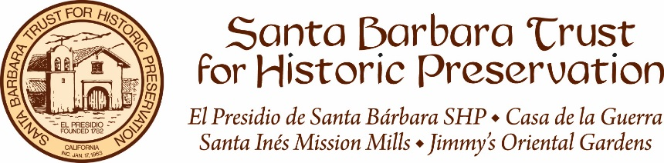
PRESS RELEASE

FOR IMMEDIATE RELEASE
Tuesday, February 5, 2019
Additional photos available upon request

PRESS CONTACT
Zach VanHarn
Santa Barbara Trust for Historic Preservation
123 East Canon Perdido Street, Santa Barbara, CA
Tel: (805) 961-5378 Fax: (805) 966-9888
E-mail: zach@sbthp.org Website: www.sbthp.org
Blog: sbthp.wordpress.com Facebook: facebook.com/SBTHP Twitter: twitter.com/SBTHP

Santa Barbara Trust for Historic Preservation Announces
New Additions to the Board of Directors

(Santa Barbara, CA) – The Santa Barbara Trust for Historic Preservation (SBTHP) is pleased to announce the election of new community leaders to its Board of Directors. At the 56th Annual Meeting and Community Awards Presentation held on January 26, members and friends of SBTHP gathered in the Chapel at El Presidio de Santa Bárbara State Historic Park. The meeting featured a review of the 2018 Annual Report and the election of new Trustees. Members elected John Doordan, Stuart Hauck, James Krautmann, and Tara Wood to join the Board for a three-year term.

John Doordan
Midwestern raised, John Doordan earned his S.B. degree from the Massachusetts Institute of Technology (MIT) in 1968. After serving as a Naval Aviator, John joined Hewlett Packard and took responsibility for Latin American distributors. He left HP to co-found a Silicon Valley startup in consumer electronics.

QAD Inc., a Santa Barbara company, recruited John as employee #6, beginning a 25 year career there. He started the Silicon Valley office, became the first Managing Director in 8 countries throughout Asia-Pacific. From his Hong Kong headquarters, he opened QAD’s successful China business in the 1990’s. After posts in Brazil and Europe, he came to Santa Barbara in 2002 to semi-retire and lead QAD’s senior manager development program, conducting leadership seminars on 5 continents.

Among John’s community concerns are financial transparency in local government and preservation of Santa Barbara’s historic heritage. His interest in history led him to the Santa Barbara Club. He is a past president, and now sits with its Board as President of the SBC Preservation Foundation. John has embraced the intertwined history of the city of Santa Barbara and those earlier Club members who founded many of our civic institutions. His personal interests include history, travel, genealogy, golf, skiing, public speaking, and investment portfolio management.

Stuart Hauck
Stuart Hauck is a construction management and administration consultant. Stuart’s clients are primarily architects, contractors and government entities involved in the construction and facilities management of schools, public buildings and military facilities. Stuart has over 42 years of facilities design and construction experience with completed projects statewide and overseas. A native Californian, Stuart attended United States International University in San Diego and UCSB. Stuart currently resides in the Santa Ynez Valley with his wife, Gayle. Stuart and Gayle have two sons, Philip and Alex, who also reside locally.

James Krautmann
James Krautmann was born in Cincinnati, Ohio, and grew up in Missouri. He graduated from Thomas Aquinas College in 2000, with a Liberal Arts degree. James began his real estate career with a local firm, Pitts and Bachmann, in 2004. In 2006, that company was purchased by a large international firm, Sotheby’s International Realty, and James continued to work with them for the next ten years. At that point, James realized the value of working for a local company with strong community ties, and made the decision to move to Village Properties, where he is currently one of their top agents. His primary focus is selling older, historic homes of character. He and his wife Andrea live in Montecito with their four children, Sam (15), Jane (13), Damien (10) and Kate (8).

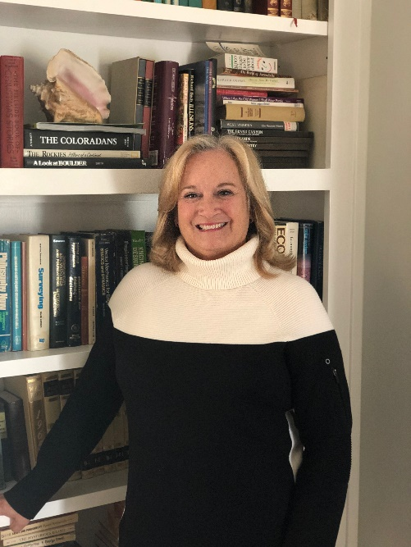
Tara Wood
Tara Wood was born and raised in Boulder Colorado where she studied history. After years of work with the Junior League and volunteering in local schools and libraries she moved to Solvang 21 years ago. She is the only person who has served on every committee the City of Solvang has as well as a term on City Council. Currently she docents at Elverhoj Museum of History and Art, and provides support to the reading specialist at Oak Valley Elementary in Buellton where she teaches students struggling with reading skills. Her personal project is Book Bug Exchange where she provides books for children and parents and gives them out at Sunnyfields Park with the hope that they will be exchanged with their friends.

The Board elected the following officers for a one-year term:
Debby Aceves, President
Kevin Nimmons, First Vice President
Anthony Grumbine, Second Vice President
Kevin Snow, Secretary
Kyle Slattery, Treasurer
Terease Chin, Immediate Past President
####

ABOUT Santa Barbara Trust for Historic Preservation (SBTHP)—For over fifty years the Santa Barbara Trust for Historic Preservation (SBTHP) has worked to protect, preserve, restore, reconstruct, and interpret historic sites in Santa Barbara County. Founded in 1963 by Dr. Pearl Chase and other concerned community leaders, SBTHP operates El Presidio de Santa Bárbara State Historic Park—Santa Barbara’s 18th century birthplace—under a unique agreement with California State Parks. The State has purchased the building that housed Jimmy’s Oriental Gardens, providing an opportunity to interpret the history of Santa Barbara’s Asian American community in the Presidio Neighborhood. SBTHP owns and operates Casa de la Guerra, the 1820s home of Presidio Comandante José de la Guerra and his family; the restored home is now a museum featuring original furnishings and rotating exhibits. In 2009, SBTHP signed an agreement with State Parks to manage and develop the Santa Inés Mission Mills, located near the town of Solvang, as a future California State Park. In 2011, SBTHP was awarded the Trustees’ Emeritus Award for Excellence in the Stewardship of Historic Sites by the National Trust for Historic Preservation. With the help of continuing education programs and exhibits, SBTHP strives to encourage community involvement and foster an appreciation for Santa Barbara County’s distinctive history. Learn more at www.sbthp.org.

